**System design:**

**MUST DO LINKS:**

[**https://github.com/donnemartin/system-design-primer#step-1-review-the-scalability-video-lecture**](https://github.com/donnemartin/system-design-primer#step-1-review-the-scalability-video-lecture)

<https://tianpan.co/notes/45-how-to-design-netflix-view-state-service>

<http://www.puncsky.com/blog/2016-02-13-crack-the-system-design-interview>

<https://en.wikipedia.org/wiki/Service-oriented_architecture>

<https://github.com/donnemartin/system-design-primer#index-of-system-design-topics>

security

<https://github.com/shieldfy/API-Security-Checklist>

**Latency Numbers:??**

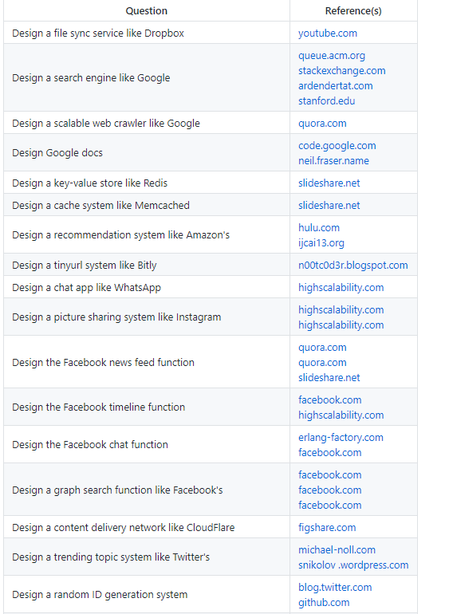

Application Layer vs Platform Layer

**DataBase Sharding criteria???**

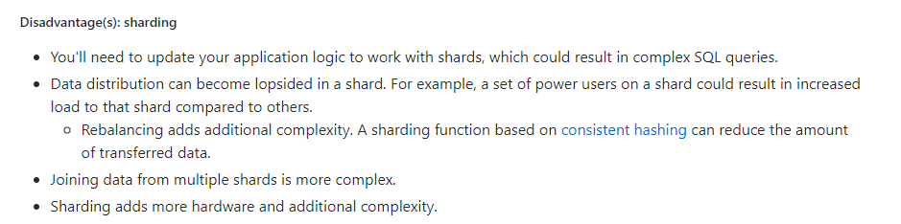

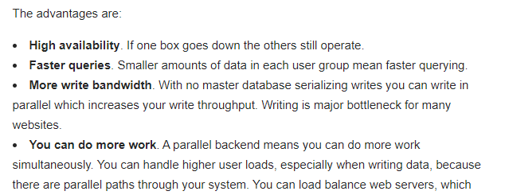

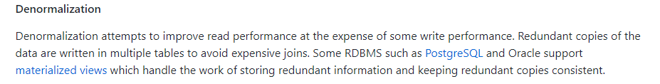

**SQL Tuning:**

**Good search indexes**

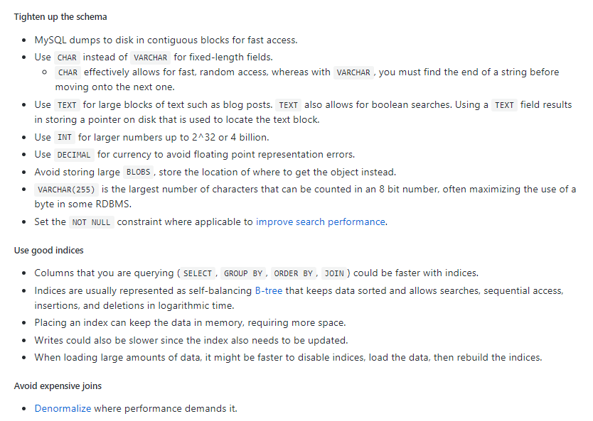

<https://www.youtube.com/watch?v=wxSAxUxK5hA&list=PLGThsaJXH1whonKUURpJ8HOXyz4az0CQE>

**performance tuning:**

<https://leetcode.com/discuss/career/216554/From-0-to-clearing-UberAppleAmazonLinkedIn>

<https://github.com/donnemartin/system-design-primer#cache>

rate Limiting algo:

<https://www.youtube.com/watch?v=FU4WlwfS3G0&list=PL0evysyBWYO4n2wkp1UgqpUfSsXnu5EMf&index=4>

System Design: Interview Bit

https://gist.github.com/vasanthk/485d1c25737e8e72759f

INTERVIEW BIT: SYSTEM Design

1.Features(2 mins)

2.estimation(5 mins): QPS 10M QPS fo scale system as twitter

**1. cache**: eviction strategy

Size in TBs

Write through cache : This is a caching system where writes go through the cache and write is confirmed as success only if writes to DB and the cache BOTH succeed. This is really useful for applications which write and re-read the information quickly. However, write latency will be higher in this case as there are writes to 2 separate systems.

Write around cache : This is a caching system where write directly goes to the DB. The cache system reads the information from DB incase of a miss. While this ensures lower write load to the cache and faster writes, this can lead to higher read latency incase of applications which write and re-read the information quickly.

Write back cache : This is a caching system where the write is directly done to the caching layer and the write is confirmed as soon as the write to the cache completes. The cache then asynchronously syncs this write to the DB. This would lead to a really quick write latency and high write throughput. But, as is the case with any non-persistent / in-memory write, we stand the risk of losing the data incase the caching layer dies. We can improve our odds by introducing having more than one replica acknowledging the write ( so that we don’t lose data if just one of the replica dies ).

**QPS: Query per sec**

Number of machines needed:

A production level caching machine would be 72G or 144G of RAM. Assuming beefier cache machines, we have 72G of main memory for 1 machine. Min. number of machine required = 30 TB / 72G which is close to 420 machines.  
Do know that this is the absolute minimum. Its possible we might need more machines because the QPS per machine is higher than we want it to be

**Design Goals:**

* **Latency** - Is this problem very latency sensitive (Or in other words, Are requests with high latency and a failing request, equally bad?). For example, search typeahead suggestions are useless if they take more than a second.
* **Consistency** - Does this problem require tight consistency? Or is it okay if things are eventually consistent?
* **Availability** - Does this problem require 100% availability?

point of caching is low latency.

**Consistemcy Vs Availability:**

Unavailability could lead to latency spikes and increased load on DB. Choosing from consistency and availability, we should prioritize for availability.

**Deep Dive/ 20 to 30mins**

LRU Cache in Single Threadded machine

Hash

**Rate Limiting:**

The requests coming a lot in number from one client and causing latency to other clients cause; noisy neighbour problem called as Throttling/Rate limiting.

**Autoscaling** a potential solution but by the time system scales; it might have already crashed due to noisy neighbour

Alternatively,max the number of threads and max connecions config. For a service end point at load balancer can be good alter. **BUT load balancer can’t distinguish between operation heavy request and that for a a process can be done at application level only**

Don’t throttle if not sure if need throlling.

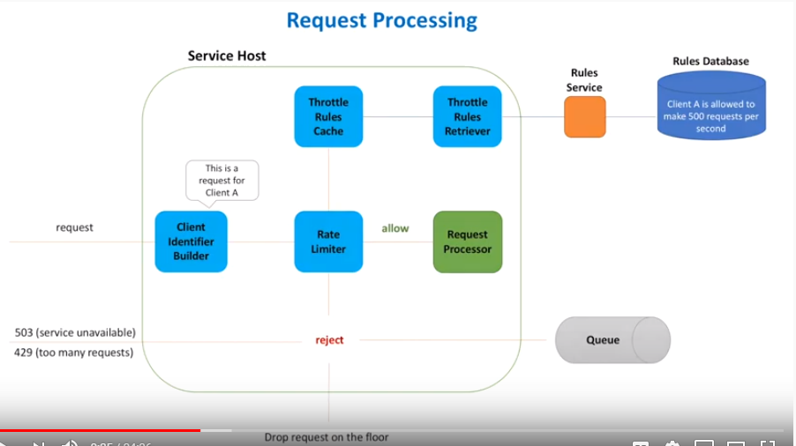

**Rate Limiter Algorithm/ OO Design for Throlling Library**

**Token Bucket Algorithm: ????**

Top K Problem (Heavy Hitters)

<https://www.youtube.com/watch?v=kx-XDoPjoHw&t=11s>

To find top k in live ; like top k videos in youtube

1. High Performance; means preprocessosed

Instagram:

<https://www.youtube.com/watch?v=hnpzNAPiC0E>

**CAP Theorem**

**CDN:**

Mer

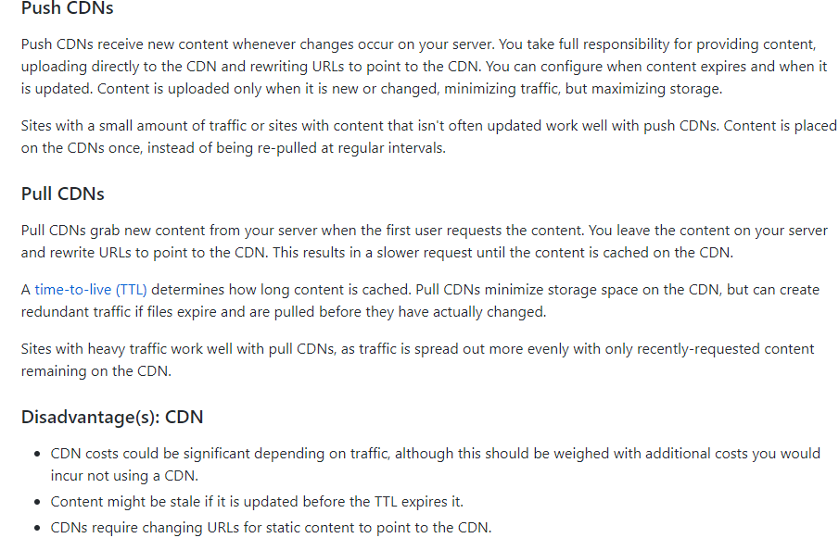

**Cached:**

**CDN** a cache type

Cache aside

Cache write through : first cache than DB

Write-behind: first cahce than in queue and than Db

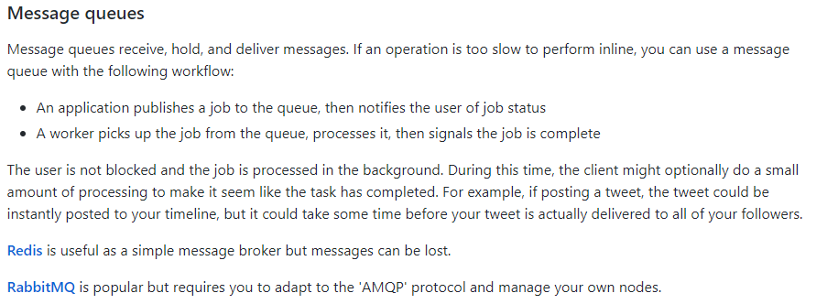

**How to approach System Design:**

1. **Google search:**

<https://softwareengineering.stackexchange.com/questions/38324/how-would-you-implement-google-search>

1. **Load Balancer:**

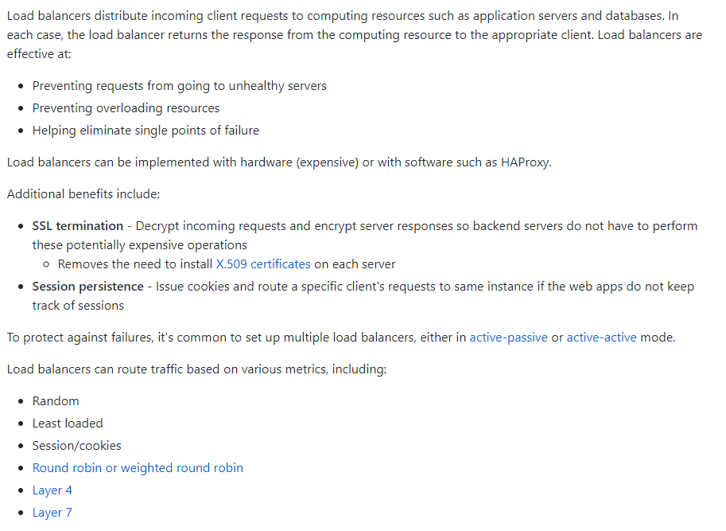

**Usecase 🡪 Functional - > non functional 🡪 constraints 🡪 bottleneck🡪 HLD 🡪 services(client protocol) 🡪 Load Balancer-🡪 Caching(!00 GB RAM for 500Byte data each request) 🡪 DB(MYSQL vs NOSQL)**

* **Fail Safe system**

**Data Replication is done asynchronously; thus is eventual Consistency as in Cassandra**

**BackOfEnvelope(Traffic and math calculation) 🡪 Service API design**

**Compare Cache with CPU computation tradeOFF**

**Does cache maintains real time/changing data? Cache only maintains traffic**

**Consider SOLID PRINCIPLE also in design as ; keep concerned separated**

**Also, explain the implemented DataStructure Algotithm**

**Auto Increment Vs features based Sharding**

**Rate Limiting and Throllting:**

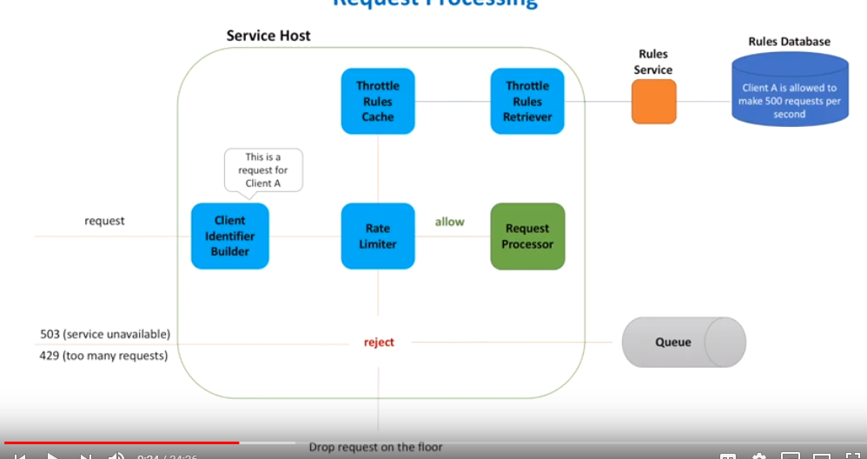

1. **Design google Map:**

<https://www.youtube.com/watch?v=lOcqPEOROwQ>

queues; used for Unsynchronous tasks vs PIPELINE

<https://github.com/donnemartin/system-design-primer>

1. **Target audience**

Interviewer: Evaluate how to deal ambiguity

Functional and Non Functional Requirements(**Usecase: Youtube**)

**Classify if:** SQL ,NOSQL(Cassandra),Cache(Redis) or stream(Kafka+Sparak) or batch processing(Hadoop and Map Reduce)

**4 categories:**

**Users/Customers**

Who and How system to be used

All Users, for individual users or Marketing

**Scale(Read and write)**

How many reads/sec, requests/sec

Are traffic spikes expected

**Performance**

Read-to-write delay accepted??

If no delay than no batch option but streaming only

**Expected latency for read queries?**

**Cost**

If dev is costly; got fot open source

If maintenance;; go for public cloud domain installation

**Functional Req:**

System behaviour, APIs

Non-Functional:

System qualities as fast, performance, fault tolerance

Ask functional req. first.

**Functional req:**

Write points on whiteboard

Make the most generalized API:

Identify name and parameters of the method

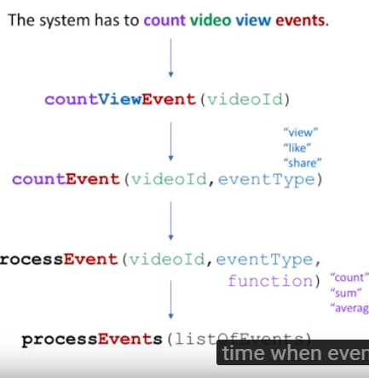

**NON-Functional:**

**Decise on CAP Theroem :** bwteeen availability and consistency

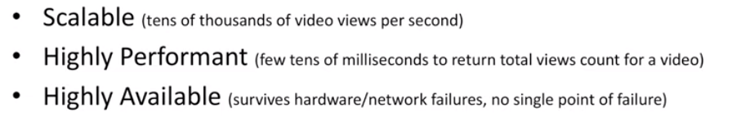

**STEP2:**

Make high level components and start explaining and drive conversation.

**Step1:** Start with data Model

**Compare the two approached for the persistence:**

**In fig:** First approach is stream processing and Later is Batch Processing

**(ASK INTERVIWER FOR APPROACH)**

**Discuss Both the approaches:**

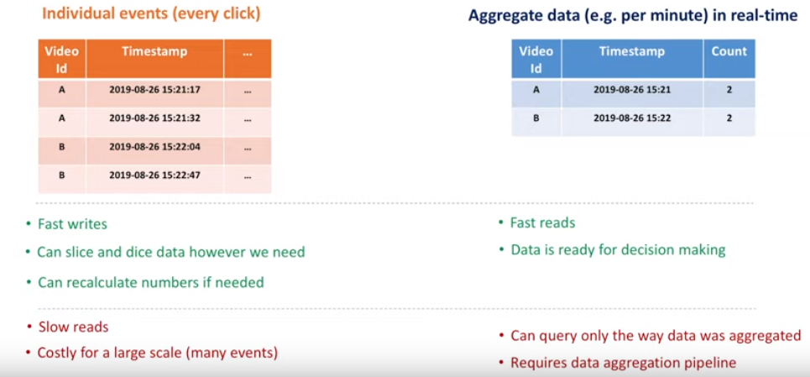

**Discuss TradeOFFs in BOTH Approaches:**

**Step2: Where to store Data**

Evaluate both SQL and NOSQL

Compare for scalability, availability

**Scale for both read/write**

* **Not to loose data if hardware failure**
* **Strong consistency and tradeOffs**
* **Data security**
* **Recover data in outage**
* **Extensible for data model change in future**
* **Cost**
* **On Premises and cloud data centers**

**For MSQL:**

Database sharding ? how it works

Maintain the proxy server/Load balancer

Shard Proxy before Database:

How shard proxy helps??

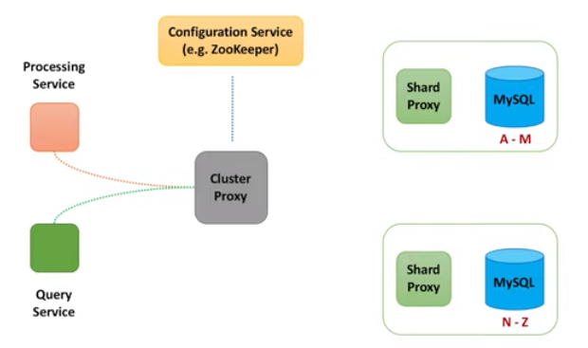

Thus attains scalabilty:

Q: **how to attain availability??**

What if DB shard dies?

Replication

Done synchronously OR unSyncronously

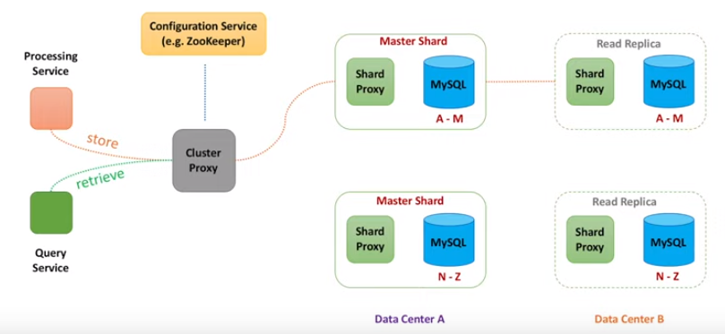

**Alternately, for NO SQL as Cassandra**

**Gossip Protocol;** used to sync data across multiple Nodes

*In SQL approach ; only proxy shard knew about all nodes BUT in NO SQL each node knows about other Nodes*

**Node can be chosen based on Round Robin algo or node closed to client in term of netword distance**

**Uses consistent hashing:**

**Starting node is coordinator Node**

**Has Quorum read and quoram wrte approach**

There might be the stale data as one not misses thus **; eventual Consistency**

**For Non Functional req: Availabilty dominates consistency**

**As Data is replicated Asyncronously and inconsistency is temporary**

**Step 3: How to store Data**

**Report Building:**

Need join across if using RDBMS:

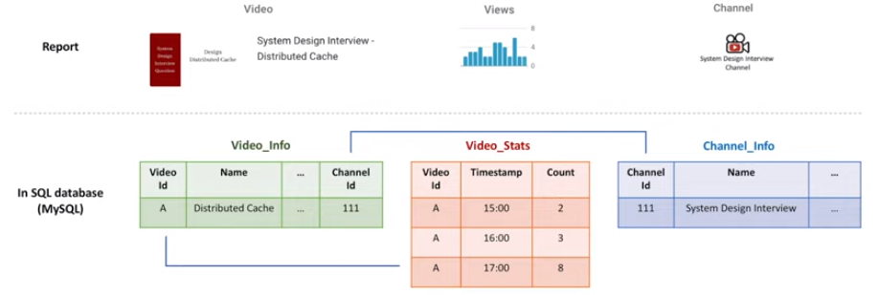

Advantage: Normalization hence, less data redundancy

**In case of NO SQL:**

Think as query

Add column for every other transaction / hour

Prefer Cassandra as; its best for Real time analysis

**Compare which NOSQL needed for which purpose?**

Types of NOSQL

* Column
* Doc
* Key-value
* Graph

**Data Processing:**

ProcessingService:

Write requirements on White Board:

Scalable == portioning

Reliable == replica and checkpoint

Fast == in memory

**Data Aggregation basics:**

Prefer Second option: In-Memory Counter

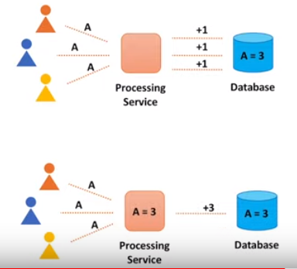

Push the changes from processService or PULL?

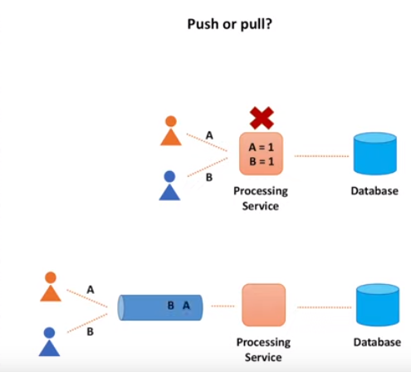

**CheckPointing:**

In StreamData Processing:

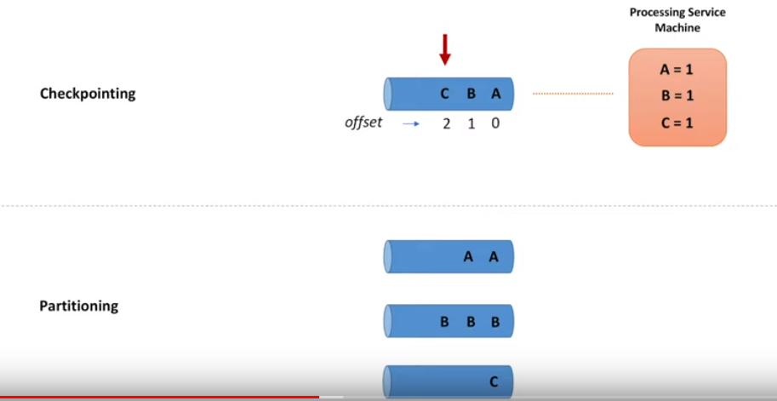

Uses Hashing to pick a queue to parse the message

**ThroughPut Vs MultipleThreads???**

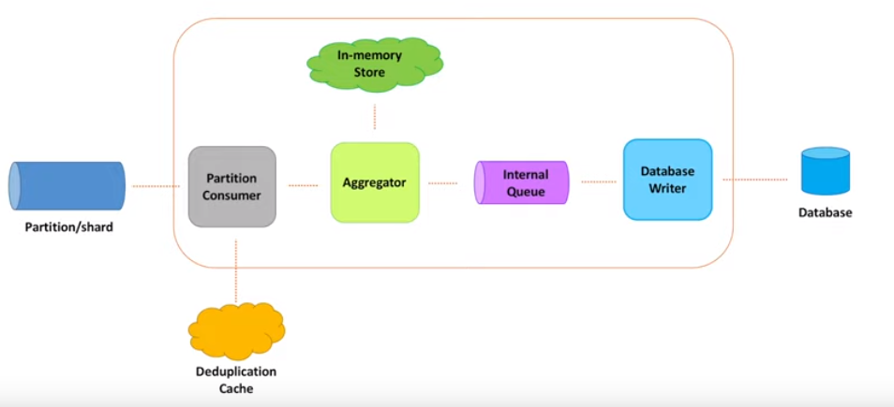

Use of **Dead-letter Queue**:

Database in same machine where processService is residing: called Embedded DB; thus lessens the need for remote call

**StateManagement for Objects stored in In-Memory: How to deal iff machine fails?**

**Thus use Store data.**

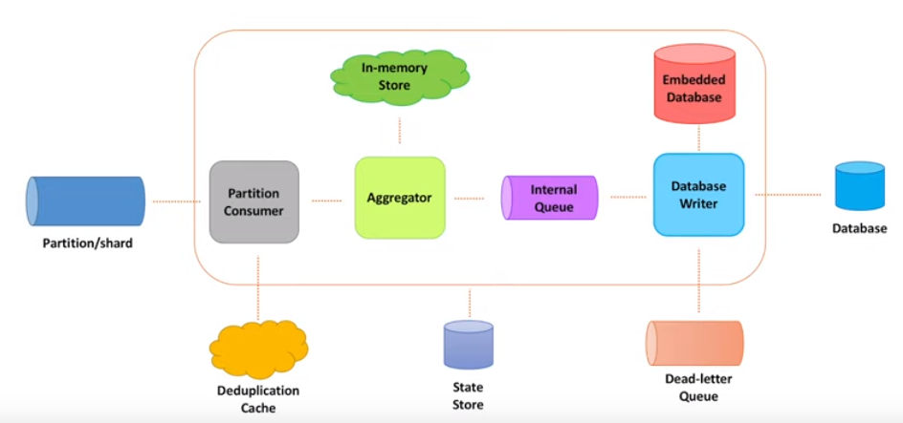

**Data Ingestion:**

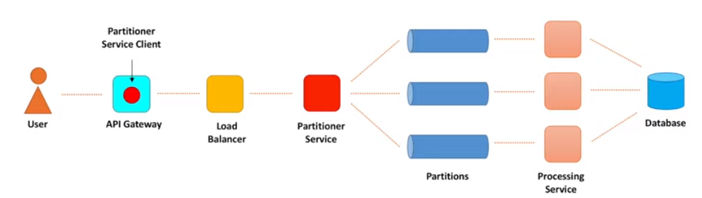

Ingestion path component:

**Blocking I/O Vs Non-Blocking I/O**

The thread create a connection and blocks the socket as well

One thread/connection??

Rate Limiter: Important here

Non-Blocking Systems have: High ThroughPut

Than why so many Blocking I/O system??

Tracking is problematic in Non-Blocking BUT Blocking I/O has thread stack to track progress

And also Unefficient as makes system too huge and complex

**Buffering vs Batching::???**

**Timeouts:**

Connection timeout: client willing to wait for connection to get established; time is usually too low < 3 ms

Request Timeout: when request process takes time; need to evaluate latency %tile(as 1 out of 1000 req. will get timeout); option is to Re-Try

**Exponential Backoff time and jitter: value to fix min. time between re-tries**

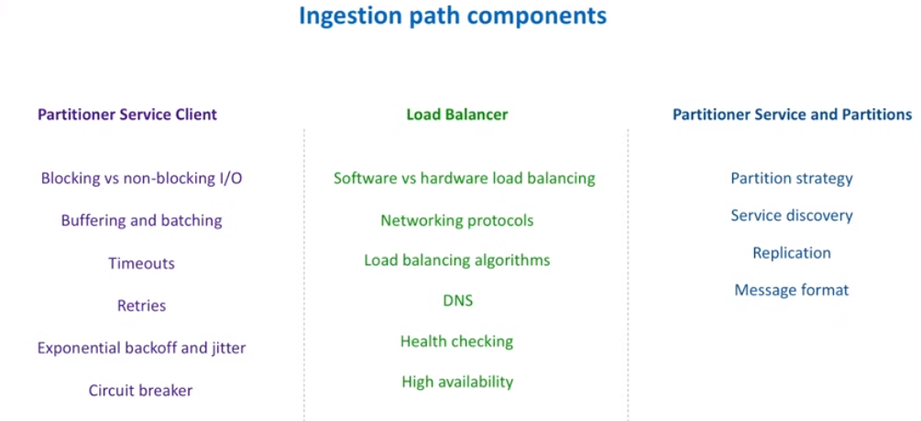

**SOLID PRINCIPLE:**

**Single responsibility:**

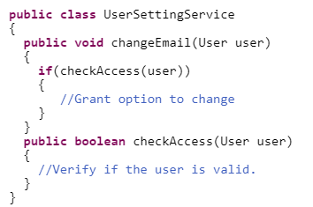

**Open and closed:**

Code to interface; so no if-else rather extend to create new class instead

**Interface segregation Principle:**

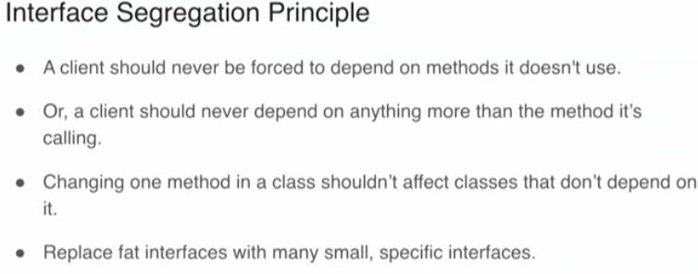

Unnessaray forced implementation

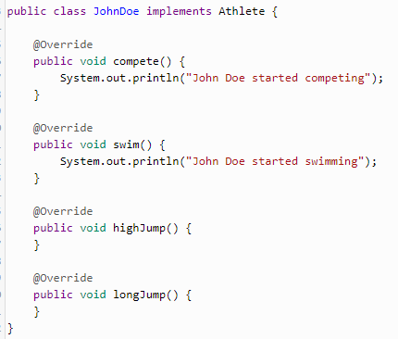

Dependency Inversion

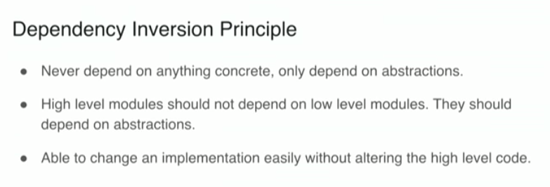

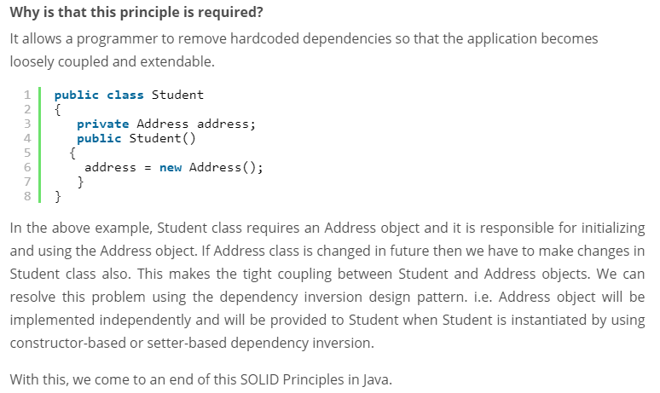

**API Gateway:**

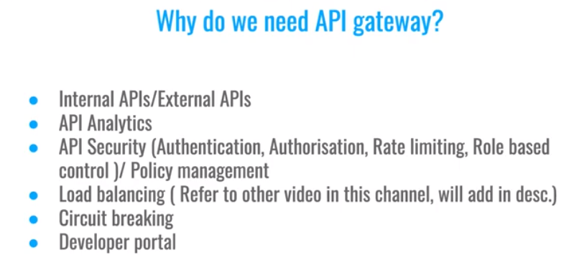

**Reverse Proxy:**

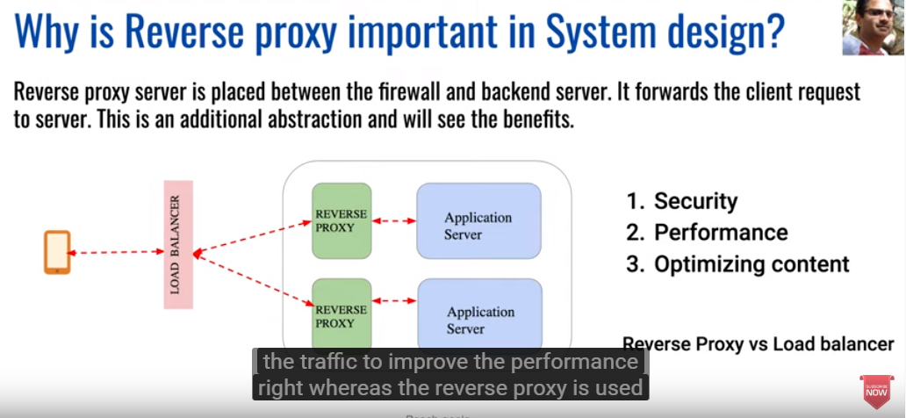

**Microservices Registry:**

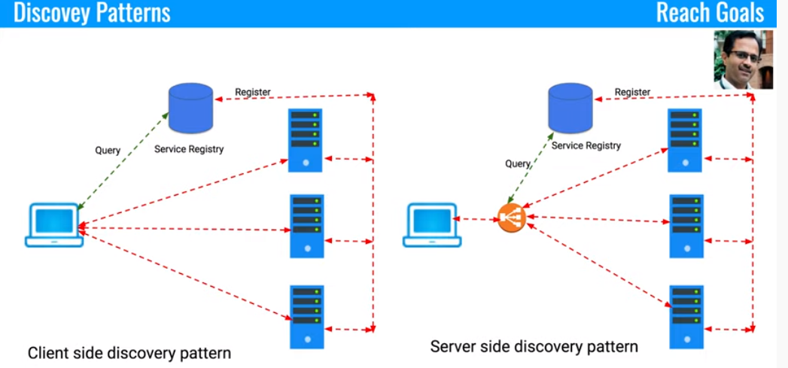

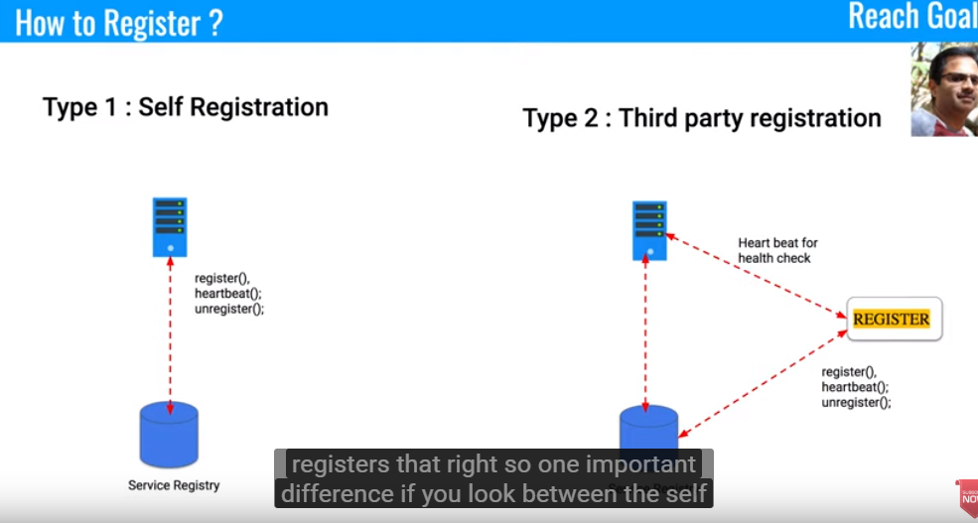

**HTTP Polling:**

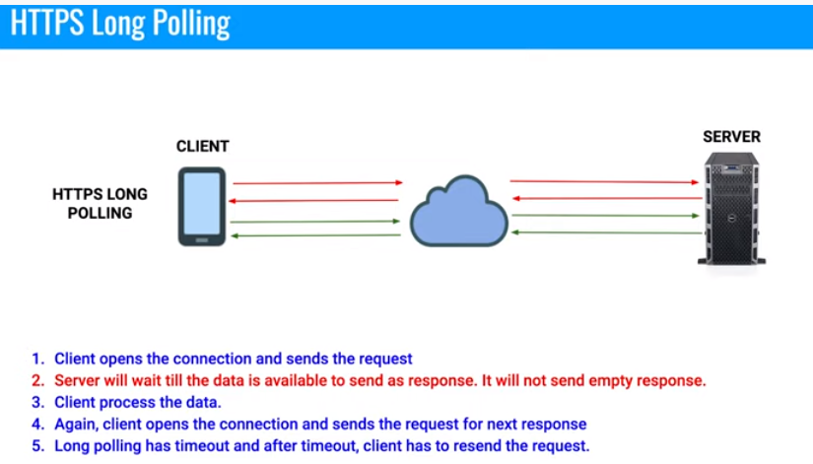

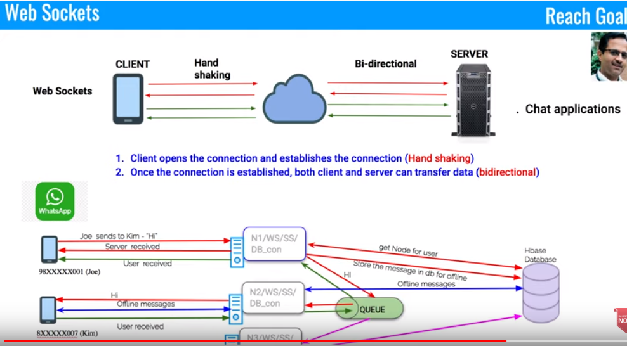

**DataBase Sharding:**

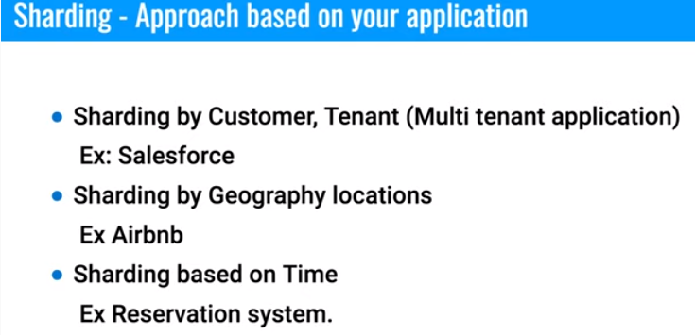

**SOLID PRINCIPLE:**

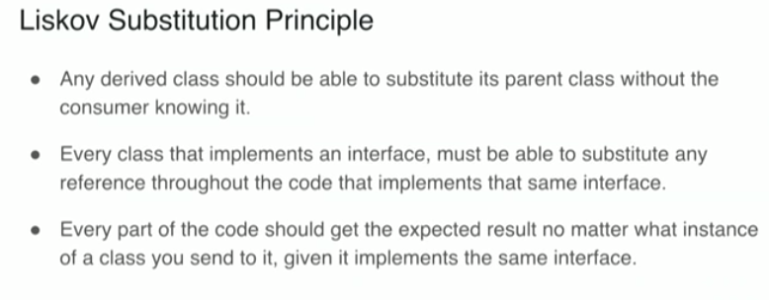

**Circuit Breakers:**

**Instagram:**

**Design whatssup:**

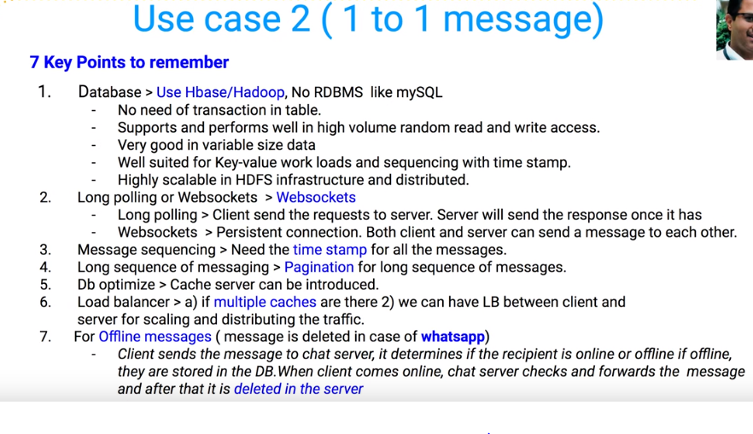

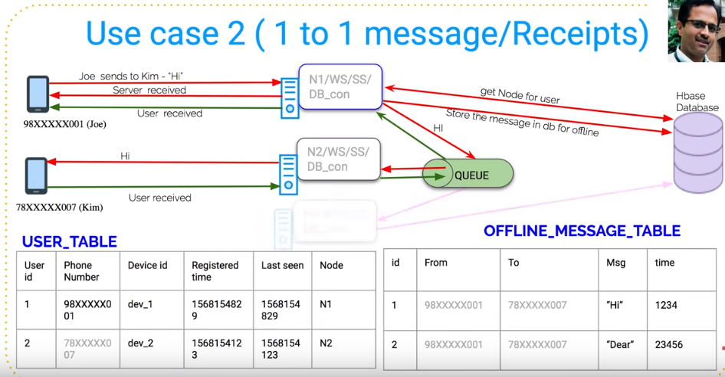

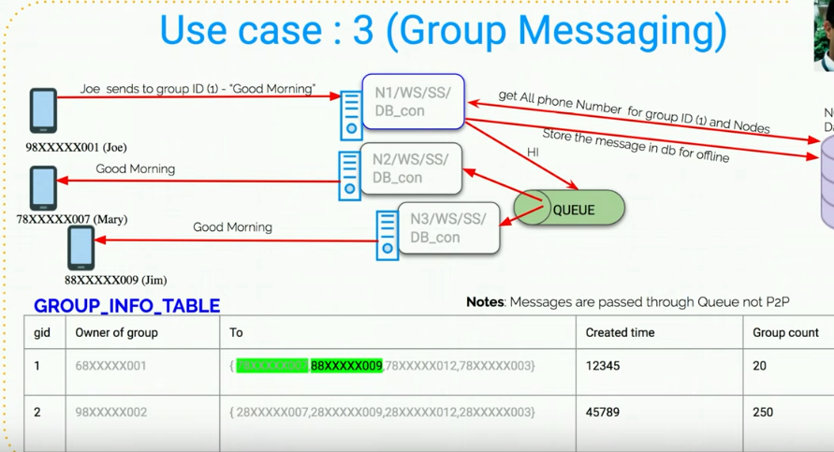

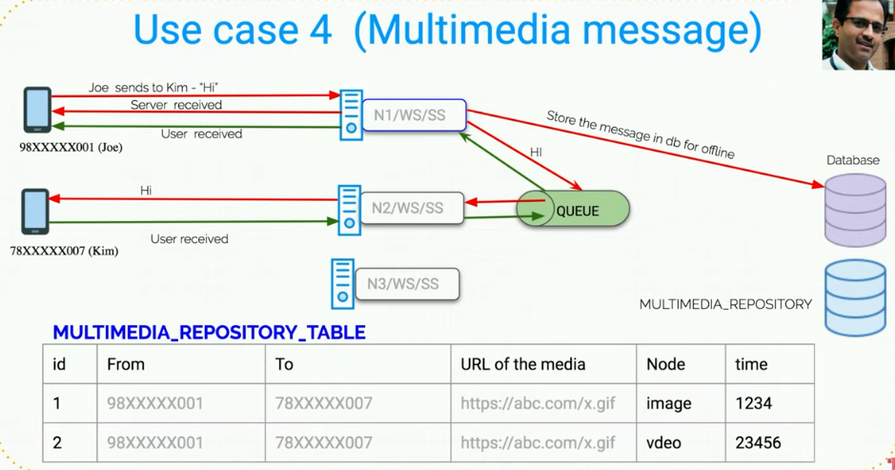

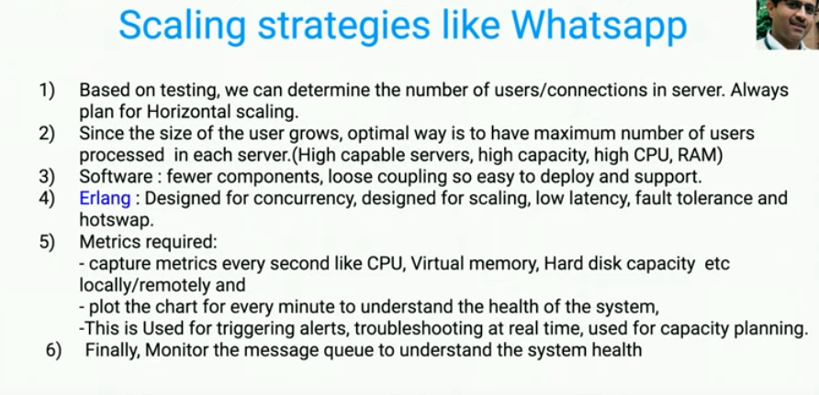

**Twitter System Design:**

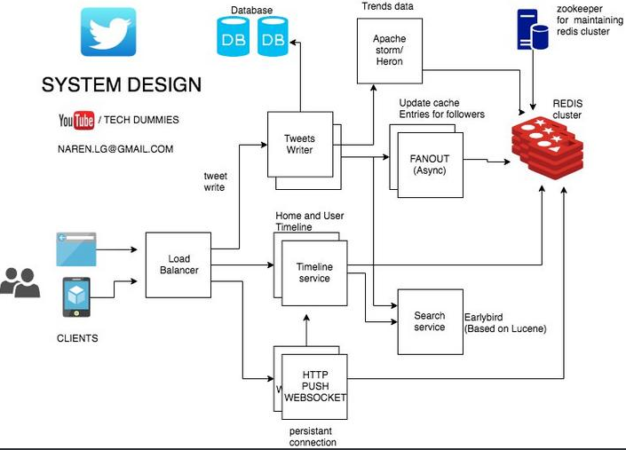

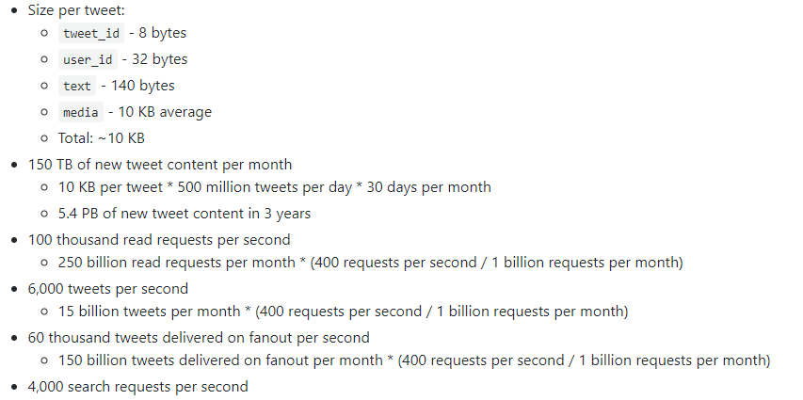

t's important to discuss what bottlenecks you might encounter with the initial design and how you might address each of them. For example, what issues are addressed by adding a **Load Balancer** with multiple **Web Servers**? **CDN**? **Master-Slave Replicas**? What are the alternatives and **Trade-Offs** for each?

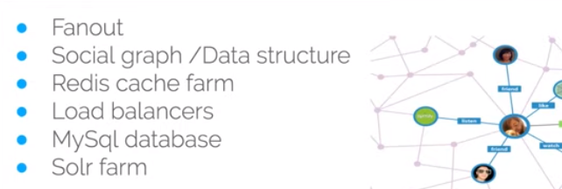

**Solr Farm or Elastic Search**

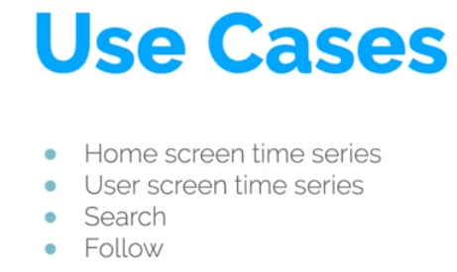

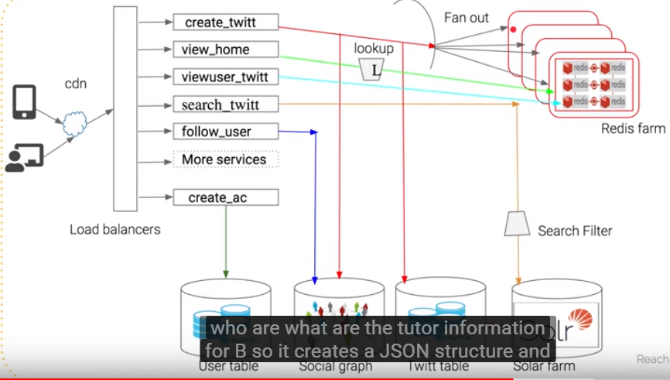

**Features:**

* **Tweet**
* **Timeline : Home timeline / User timeline / Search Timeline**
* **Trends**

Read heavy

**Eventual consistency**: consistency not major factor

Storage cost??

User Table | Tweets Table | Follower Table

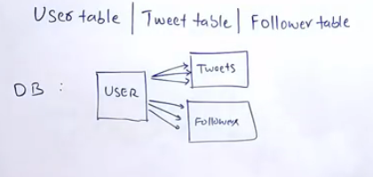

Caching layer needed for a read heavy Twitter

In redis the structure to be as :

User_ID : USER_treet IDS[1,2,3………….] as list

Tweet_ID: User_id

BottleNeck is multiple DB queries: Alternatively: NoSQL/Nodes

Data need to create the Hometimeline? Using **FANOUT** to push the tweet made by person to his followers into there individual Home Timeline Cache

Get the tweets from the Cache rather than from Database based on User ID

how much latency is acceptable in database query?

How much fast does a Cache makes the operation as compared to DB query?

Also maintain HomeTimeLine in Redis Cache

Do we need to precompile the HT and UT for user who haven’t logged to their twitter account?

No,We can avoid the processing

**#Trends:**

*Streaming????*

Stream processing Framwork as **Apache Storm**

**Or Kakfa**

ZooKeeper??

Use cache against distributed DB / nodes using FANOUT

Redis a cache db??

API are exposed form Redis to be consumed further

**In memory database?? How Redis maintains persistence of data when machine crashes**

Trends: volume of data/ **stream processing: storm or kafka**

Validation

Indexinf for seach/ lucene

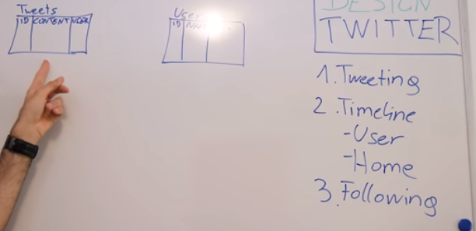

**Sending tweets**

**Eventual consistency:**

**URL Shortener:**

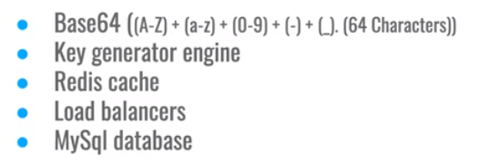



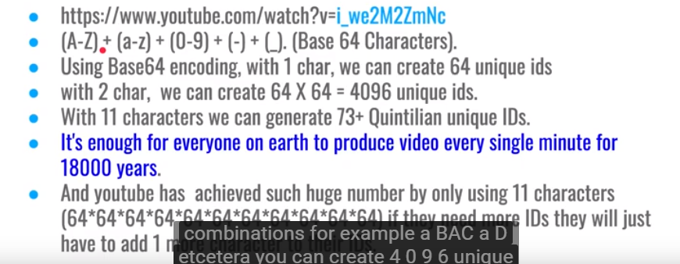

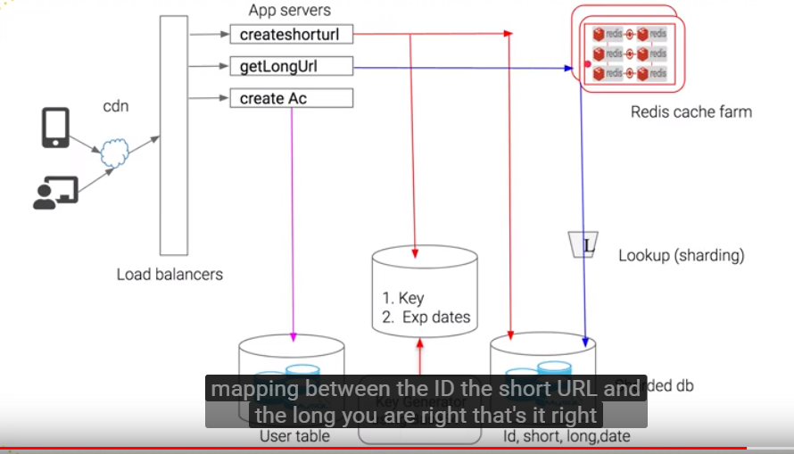

**DataBase sharding: Based on expiration date**

**Tiny URL**

1. Load of requests
2. Character of bytes for short url
3. 1 million user / month
4. Mapping between Actual Url and tiny URL
5. Prequeisite:
6. The size of data to be inserted into Database:
7. Called :DataCapacity Model

**Details to persist in database:**

**LongURL | ShortURL | created time(epoch) | expiry at**

**The above is entry of data per URL Shortener**

Now, to decide the database: DBMS or NOSQL need to understand the number of read/ write operations

The TinyURL have a ***domain.name/uniqueCode***

The Unique Code is generated:

Base 62 / Md5 Hash

MD5 takes string as input and might give outputs with collision

So use Base 62 and Base 10

As Base 62 has values from A_ Z , a-z and 0-9

Hence, 62 pow 7 will give 3.5 trillion combinations of UniqueIds

**Database:**

RDBMS: ACID but not scalable as per month 30 Million read/write

NO SQL: Highly Available, scalable BUT *Eventual Consistency*

Use base 62 libraray to convert ramdomnumber to base 62

<https://www.youtube.com/watch?v=bUHFg8CZFws>

BEHAVIROL QUESTIONS:

<https://leetcode.com/discuss/interview-experience/468811/Amazon-or-SDE2-or-Seattle-or-Dec-2019-Offer>

Tell me about a time when you had to work on something after you have delivered it  
How did you handle a tight deadline?  
What aspects would you improve if you had to do it again?  
Tell me about a time you had to handle conflict  
Tell me about a time you disagreed with your team  
Tell me about a time when you went out of your way in your company

<https://leetcode.com/problems/group-anagrams/>

<https://github.com/donnemartin/system-design-primer>

**>>>>>>>>>>>>>>>>>>>>>>>>**

**LEETCODE DESIGN QUESTIONS:**

Design a system that checks the health of 10,000 nodes. Each of 10,000 modes have an API exposed that you have to call and check the health. This API takes 1-5 seconds to respond. There is UI which tells which nodes are healthy OR not healthy. Your system should provide API for this UI. This UI refreshes every 10 mins. So, every 10 mins your system should be able to update data about those 10,000 nodes

**Java**

**Jvm Architecture:**

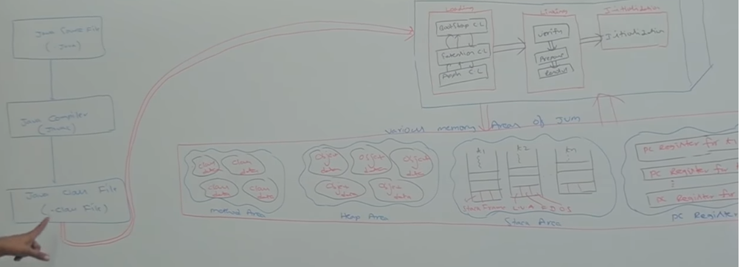

<https://www.youtube.com/watch?v=dncpVFP1JeQ>

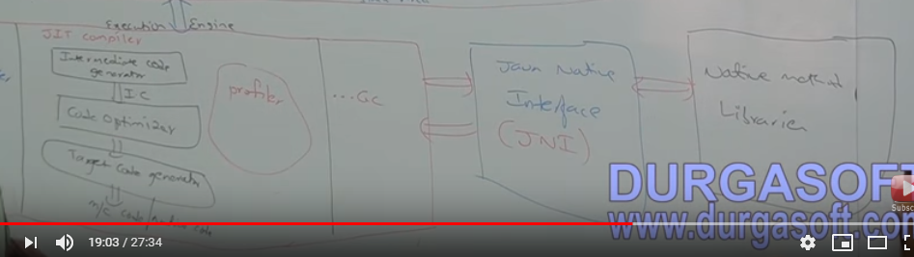

**Current product:**

* Working on Information Governance Catalog to expose the OMRS compliant metadata across the Application instances. Contributing to product, for Business Glossary, the microservices paradigm-based development.

Watson Data Platform Business Glossary microservice code

Along with tool that gets accomdated into the suite the traditional centralize metadata in a repository gets problematic; thus, the metadata repo. Grows we get into the

**Open Metadata Repository Cohort**

A Collection of Metadata Repositories sharing metadata using OMRS

**Cohort Kafka Topic**: created on enterprise server to communicate between supported repositories.

* **IIS Source;**

Collection of IIS 117+ server and UG node

* **IIS Target;**

Collection of IIS 117+ server and UG node

* **OMAG pod:**

Docker based version of OMRS service hosted in UG node

* **IGC - event mapper**

Reads mesages from IIS and converts in the OMRS format

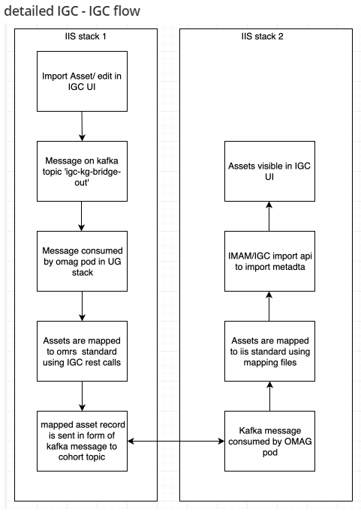

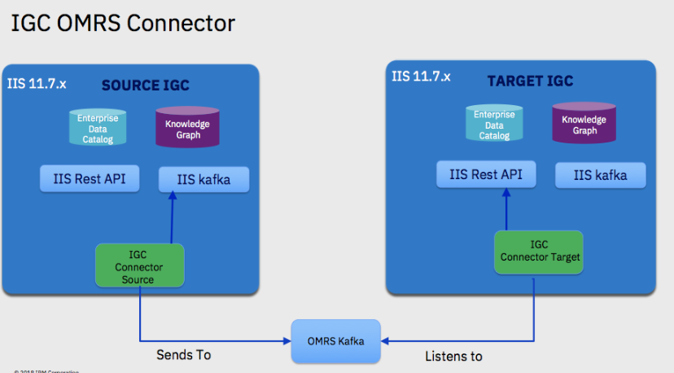

* Working on suite of products, a data Integration Platform, that deals with the data Governance with a centralized Metadata Repository, a RDBMS based persistence layer. Working on Services tier used to unify Metadata for other logical tiers of Suite comprising of different products.

METADATA APPLICATION:

<https://www.youtube.com/watch?v=k1jR2jV44LQ&list=PLmVWZ6sPOWL0kj9L_K6oRTGYdpdAxGThr&index=2>

**Information Governance:**

**For instance for Customer Sales.**

Find use and govern data. Search assets based on Business relevant term as there is NO specific Database name for term

All get details in drill Down chart and ask steward or Data Lineage

The architecture is **service-oriented**, enabling IBM InfoSphere Information Server to work within evolving enterprise service-oriented architectures. A service-oriented architecture also **connects the individual suite product modules** of InfoSphere Information Server.

InfoSphere Information Server is **built on a unified metadata infrastructure that enables shared understanding between business and technical domains**.

All functions of InfoSphere Information Server **share the same metamodel, making it easier for different roles and functions to collaborate**

 Common functions such as catalog browsing, metadata import, query, and data browsing all expose underlying common services in a uniform way

IGC a web based tool that allows to explore, understand and analyse information of asset in information Lifecycle and explains the relation of other assets in Enterprise . To coordinate between IT team and Business Team(IT to business Mapping)

Glossary of Business Terms and to manage Lineage.

Metadata Repository:

stores metadata from suite tools and external tools and databases and enables sharing among them. You can import metadata into the repository from various sources, export metadata by various methods, and transfer metadata assets between design, test, and production repositories

This is a shared Repository so the changes made by one tool are automatically available to other tools of the suite.

The single repository ensures that database table imported from database can be further used by other components as:

* For analysis in Information Analyser
* TO create table definitions in IBM Infosphere DataStage

**Category of Metadata:**

* Business Metadata: **Provides Business Context for Information Technology Assets** and adds business meaning to artifacts that are created and managed by other IT Applications.

Business Metadata includes: Glossary Terms

* Operational Metadata: IGC creates the data lineage reports that combine design and operational informations.
* Techinical Metadata: Implemented Data Resources as: host computers, databases
* Improvised the Database Query performance using Materialized View.

**OMRS**: Open Metadata Repository Service

<https://pages.github.ibm.com/InformationServer/omrs-igc/user_docs/basic_terminology/>

IBM Infosphere Information Governance Catalog

IGC a web based tool that allows to explore, understand and analyse information. To coordinate between IT team and Business Team(IT to business Mapping)

Glossary of Business Terms and to manage Lineage.

Metadata Repository:

stores metadata from suite tools and external tools and databases and enables sharing among them. You can import metadata into the repository from various sources, export metadata by various methods, and transfer metadata assets between design, test, and production repositories

This is a shared Repository so the changes made by one tool are automatically available to other tools of the suite.

The single repository ensures that database table imported from database can be further used by other components as:

* For analysis in Information Analyser
* TO create table definitions in IBM Infosphere DataStage

Category of Metadata:

Design time metadata and Operational Metadata

>>>>>>>>>>>>>>>>>>>>>>>>>>>>>

Client tier:

1. Administrative Client

DataStage Client, Server web Console

1. User Client

Service agents are used to connect services tier and Engine tier

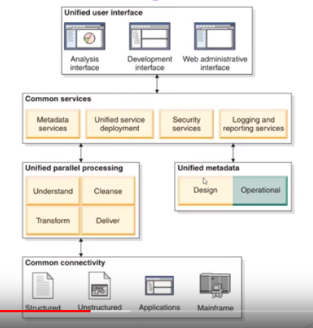

Glosssary-service:

From importServcie.java:

registerImportThread

starting: **AbstractImportThread.java** constructor

CsvImportThread and xmlImportThread.java imports the assets: starting point.

ImportType.java has CSV and XML as enum.

testCancelImport() in AsynchronousImportTest.java

RestAPITestUtils.java importCsv() executePostRequest()

>>>>>>>>>>>>>>>>>>> POINTS COVERED>>>>>>>>>>>>>>

Streaming:

LRU Caching

Volatile

Syncronization

Generics using WDPIAPIObjects

**Starting: EditActionFilterTest.java**

**DATABASE MANAGEMENT:**

**JOINS:**

<https://www.youtube.com/watch?v=WfoFVM4svLk>

**>>>>>>>>>>>>>>>>>>>>>>>>>>>>>>>>>>>>>>>>>>>>>>>>>>>>>>**

**DataStructure and Algorithms:**

1. **Sliging Windows**
2. **BackTracking**
3. **Dynamic Programming**
4. **Heap**
5. **Array**
6. **Graph**
7. **Sorting**
8. **N-Array**

**Design REST API:**

Design REST APIs for file sharing management system (like Dropbox or Google Drive)

**>>>>>>>>>>>>>>>>>>>>>>>>>>>>>>>>>>>>>>>>>>>>>>>>>**

**OBJECT ORIENTED DESIGN QUESTIONS:**

<https://leetcode.com/discuss/interview-question/object-oriented-design/373887/Amazon-or-System-Design-or-A-configuration-management-system>

<https://leetcode.com/discuss/interview-question/object-oriented-design?currentPage=1&orderBy=hot&query=>

Elevator:

<https://leetcode.com/discuss/interview-question/124660/design-an-Elevator>

Design MALL

<https://leetcode.com/discuss/interview-question/object-oriented-design/125114/Design-a-rest-api-representing-a-Hotel-Booking-system.>

Hotel Booking REST APPI:

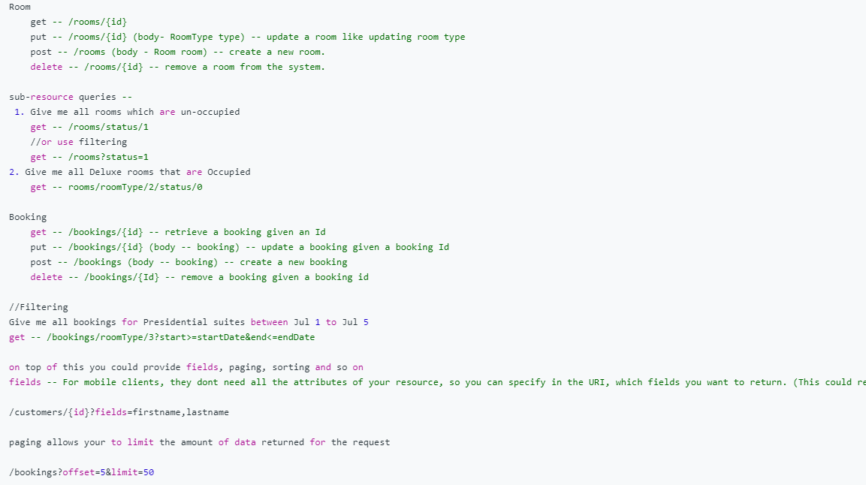

uml AND ood???

**Garbage collector:**

**Marks(walks through object graph)**

**---🡪 Delete/seep-----🡪 Compact(makes allocation contiguous than fragmented)**

Garbage collector works as basis of the age of object age; like:

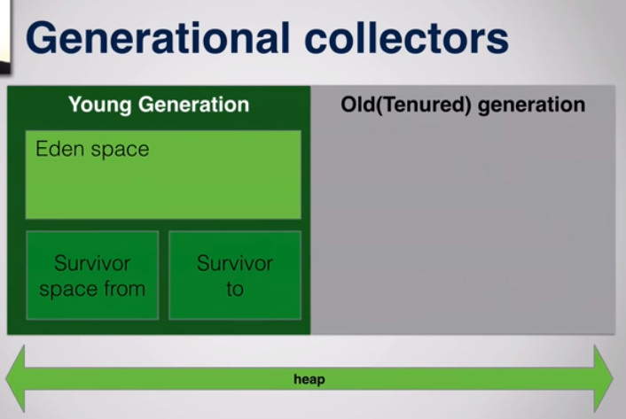

New Object(): Eden space

Survivor space: when edan space full : objects rae moved from Eden space to Survivor space ; the objects that survice the GC

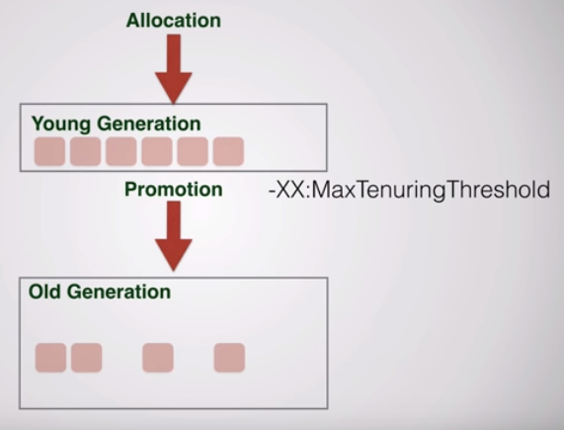

The objects that survives multiple cycles of GC moves to oled generation

MICROSERVIES

<https://www.youtube.com/watch?v=8BPDv038oMI>

**Distributed tracing : using New Relic**

**Time the request takes**

**Synchronization in microservices**

**Microservices:**

<https://www.youtube.com/watch?v=o8RO38KbWvA&list=PLqq-6Pq4lTTbXZY_elyGv7IkKrfkSrX5e>

level1:

<https://www.youtube.com/watch?v=y8IQb4ofjDo&list=PLqq-6Pq4lTTZSKAFG6aCDVDP86Qx4lNas>

level2:

Behavirol:

1. Important task:

>>>>>>>>>>>>>>>>>>>>>>

DS:revison 1:

21. https://leetcode.com/problems/insert-into-a-binary-search-tree/submissions/

22. https://leetcode.com/problems/binary-tree-paths/submissions/

23. https://leetcode.com/problems/invert-binary-tree/submissions/

To try myself:======================

https://leetcode.com/problems/all-nodes-distance-k-in-binary-tree/submissions/

OR

https://www.geeksforgeeks.org/print-nodes-distance-k-given-node-binary-tree/

24. https://leetcode.com/problems/convert-bst-to-greater-tree/

25. https://leetcode.com/problems/remove-linked-list-elements/submissions/

>>>>>>>>>>>

https://www.youtube.com/watch?v=HXV3zeQKqGY&t=6239s

26. https://leetcode.com/problems/remove-linked-list-elements/submissions/

27. https://leetcode.com/problems/intersection-of-two-linked-lists/

28. https://leetcode.com/problems/intersection-of-two-linked-lists/

29. https://leetcode.com/problems/number-of-islands/

30. sliding window:

https://leetcode.com/problems/fruit-into-baskets/discuss/429641/Clean-sliding-window-based-JAVA-solution

32. https://leetcode.com/problems/first-unique-character-in-a-string/

33. https://leetcode.com/problems/employee-importance/-- RE DO

34. rotten oranges:

https://leetcode.com/problems/rotting-oranges/submissions/

35.

https://leetcode.com/problems/word-search/

36.

https://leetcode.com/problems/container-with-most-water/submissions/

37.

https://leetcode.com/problems/unique-email-addresses/

38.

meeting room:

https://www.youtube.com/watch?v=PWgFnSygweI&list=PLi9RQVmJD2fZgRyOunLyt94uVbJL43pZ_&index=18

(meeting room)

39.

https://leetcode.com/problems/battleships-in-a-board/

like robot movement

40.

https://leetcode.com/problems/combination-sum-ii/

https://leetcode.com/problems/partition-equal-subset-sum/

https://leetcode.com/problems/longest-common-prefix/

https://leetcode.com/problems/count-primes/

https://leetcode.com/problems/decode-ways/

https://leetcode.com/problems/valid-palindrome-ii/submissions/

https://leetcode.com/problems/path-sum-ii/

https://leetcode.com/problems/binary-tree-right-side-view/

(Do using recursion)

https://leetcode.com/problems/task-scheduler/

https://leetcode.com/problems/max-area-of-island/

https://leetcode.com/problems/repeated-dna-sequences/

https://leetcode.com/problems/k-closest-points-to-origin/submissions/

https://leetcode.com/problems/kth-smallest-element-in-a-bst/submissions/

(WHY ARRAY and NOT int variable)

https://leetcode.com/problems/top-k-frequent-words/

https://leetcode.com/problems/reorganize-string/

??

https://leetcode.com/problems/network-delay-time/discuss/434226/Simple-modular-Java-solution-using-PQ-for-slow-learners-like-myself

https://leetcode.com/problems/network-delay-time/

https://leetcode.com/problems/cheapest-flights-within-k-stops/

(IMPORTANT GRAPH)

https://leetcode.com/problems/find-k-pairs-with-smallest-sums/

TWITTER DESIGN:

https://leetcode.com/problems/design-twitter/

>>>>>>>>>>>>>>>>>>>>>>>>>>>>>>>>>>>>>>>>>>

DP

>>>>>>>>>>>>>>>>>>>>>>>>>>>>>>>>>>>>>>>>>>>

https://leetcode.com/problems/counting-bits/

https://leetcode.com/problems/palindromic-substrings/

https://leetcode.com/problems/stone-game/solution/

https://leetcode.com/problems/minimum-falling-path-sum/

https://leetcode.com/problems/minimum-falling-path-sum/

https://leetcode.com/problems/longest-common-subsequence/

>>>>>>>>>>>>>>>>>>>>>>>>>>>>>>>>>>>>>>>>>>>>

Sort

>>>>>>>>>>>>>>>>>>>>>>>>>>>>>>>>>>>>>>>>>>>>

https://leetcode.com/problems/intersection-of-two-arrays-ii/

https://leetcode.com/problems/sort-colors/

using comparator

>>>>>>>>>>>>>>>>>>>>>>>>>>>>>>>>>>>>>>>>>>>>>>>>

heap

>>>>>>>>>>>>>>>>>>>>>>>>>>>

https://leetcode.com/problems/reorganize-string/

(MOST IMPO)

41.

https://leetcode.com/problems/group-anagrams/

42.

https://www.youtube.com/watch?v=blUwDD6JYaE&list=PLi9RQVmJD2fZgRyOunLyt94uVbJL43pZ_&index=6

43.

https://leetcode.com/problems/letter-combinations-of-a-phone-number/

44.

https://leetcode.com/problems/is-subsequence/submissions/

(using recusrion??)

45.

https://leetcode.com/problems/frog-jump/

46.

https://leetcode.com/problems/delete-nodes-and-return-forest/

(NO IDEA)

47.

https://leetcode.com/problems/coin-change/

48.

https://leetcode.com/problems/partition-labels/

49.

https://leetcode.com/problems/longest-common-prefix/

50.

https://leetcode.com/problems/license-key-formatting/

51.

https://leetcode.com/problems/add-binary/

52.

https://leetcode.com/problems/word-search/submissions/

53.

https://leetcode.com/problems/path-sum-ii/

54.

https://leetcode.com/problems/binary-tree-paths/

why only String works and NOT stringBuffer????

55.

https://leetcode.com/problems/find-peak-element/

56.

https://leetcode.com/problems/valid-anagram/submissions/(why count array as -'a')

57.

https://leetcode.com/problems/plus-one/submissions/

58.

https://leetcode.com/problems/valid-parentheses/

59.

https://leetcode.com/problems/remove-duplicates-from-sorted-array/

------------ TO DO--------

60.https://leetcode.com/problems/contains-duplicate-ii/

https://leetcode.com/problems/reverse-integer/submissions/

61.

https://leetcode.com/problems/relative-sort-array/

https://mail.yahoo.com/d/folders/1/messages/1031?.intl=in&.lang=en-IN&.partner=none&.src=fp

https://leetcode.com/problems/hamming-distance/submissions/

61.

https://leetcode.com/problems/single-number-iii/

62.

https://leetcode.com/problems/kth-largest-element-in-a-stream/

https://leetcode.com/problems/find-common-characters/

63.

https://leetcode.com/problems/3sum/

33 * 56.4

1863.9

https://www.youtube.com/watch?v=5NQjLBuNL0I&t=19396s

CREDIT CARD STATUS:

19L02545716270S3

>>>>>>>>>>>>>>>>>>>>>>>>>>>>>>>>>

System design interview questions:

https://gist.github.com/vasanthk/485d1c25737e8e72759f

57.

https://leetcode.com/problems/reverse-integer/

58.

>>>>>>>>>>>>>>>>>>>>>>>>>>>>>>>>>>>>>>>>>>>>>>>>>>>>>>>>>>>>>>>>>>>>>>>>>>>>>>>>

System Design

>>>>>>>>>>>>>>>>>>>>>>>>>>>>>>>>>>>>>>>>>>>>>>>>>>>>>>>>>>>>>>>>>>>>>>>>>>>>>>>>>

1. log polling; for feed

https://leetcode.com/discuss/career/216554/from-0-to-clearing-uberappleamazonlinkedingoogle

https://leetcode.com/problems/sum-of-two-integers/

https://leetcode.com/problems/happy-number/

https://leetcode.com/problems/magic-squares-in-grid/

https://leetcode.com/problems/number-of-1-bits/submissions/

https://leetcode.com/problems/3sum/

https://leetcode.com/problems/circular-array-loop/

https://leetcode.com/problems/invalid-transactions/

https://leetcode.com/problems/sum-of-subarray-minimums/

https://leetcode.com/problems/maximum-product-subarray/

https://leetcode.com/problems/jump-game/

>>>>>>>>>>>>>>>>>>>>>>>>>>>>>>>>>>>>>>>>>>>>>>>>>>>>>>>>>>>> PHASE 2:======================

TO DO:(Nick White)

907

152

209

https://www.youtube.com/watch?v=QdVrY3stDD4

https://leetcode.com/problems/pascals-triangle/

min stack/

https://leetcode.com/problems/find-all-duplicates-in-an-array/

https://leetcode.com/problems/repeated-substring-pattern/

https://leetcode.com/problems/product-of-array-except-self/

https://leetcode.com/problems/longest-repeating-character-replacement/

https://leetcode.com/problems/longest-substring-without-repeating-characters/

<https://leetcode.com/problems/longest-continuous-increasing-subsequence/>

>>>>>>>>>>>>>>>>>>>>>>>

PRODUCT:

 is an advanced data integration platform that enables you to cleanse, monitor, transform and deliver data. The scalable solution provides massively parallel processing capabilities to help you manage small to very large data volumes. It helps you deliver trusted information to your key business initiatives such as big data and analytics, data warehouse modernization and master data management.

**volatile:**

visibility Problem:

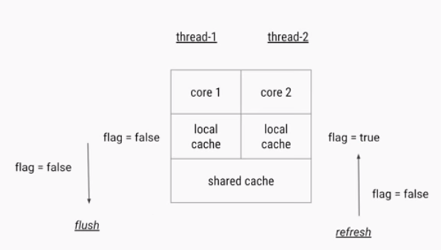

Volatile is a visibility problem while other is synchronization problem

Still volatile won’t help:

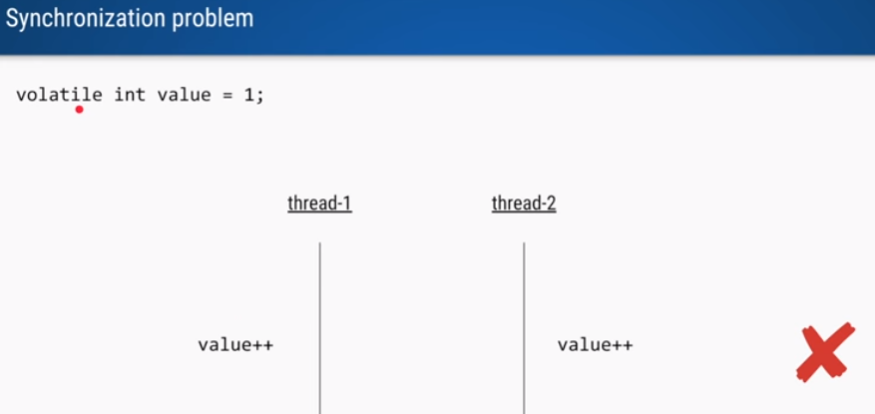

**MultiTenancy App**

Thread Local:

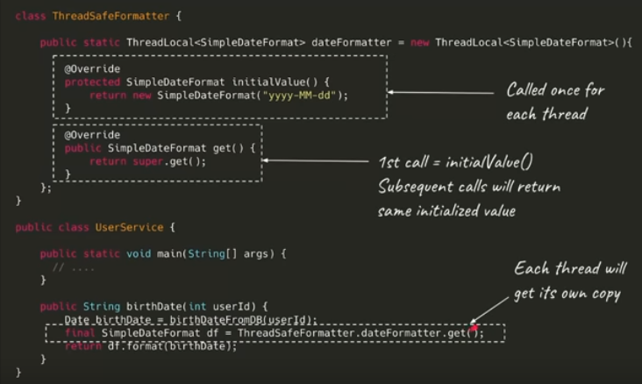

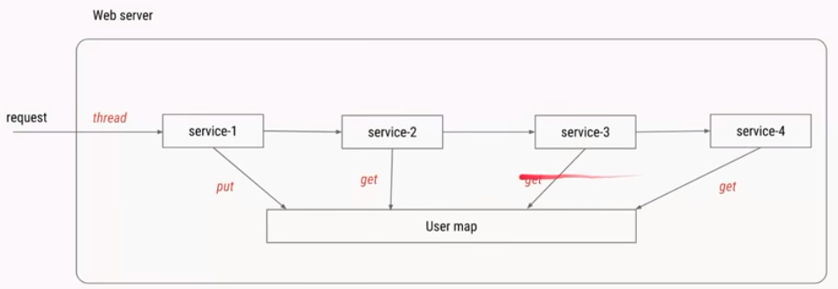

*newCachedThreadPool Vs fixedThreadPool*

<https://stackoverflow.com/questions/17957382/fixedthreadpool-vs-cachedthreadpool-the-lesser-of-two-evils>

microservices:

<https://www.youtube.com/watch?v=-PbnWGddmcM&list=PLTyWtrsGknYd0JgqeARypdRy-SX1ORYhs>

1. Cykar procy

Kubernetes is used to maintain resiliency

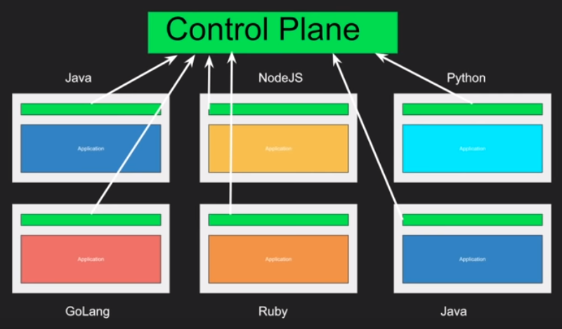

Kafka Vs RestTemplate:

For kakfa when we have multiple producers and need to split load across and batch process?

**Does OMRS useses Kafka**

Client side load balancing Vs Server Side load balancing?

ServerLoad balancers:

Software Load Balancer

Hardware load balancers

APIGateway

Kubernetes

**Syncronization:**

**Semaphore vs reentrant lock vs reentrabt read write lock**

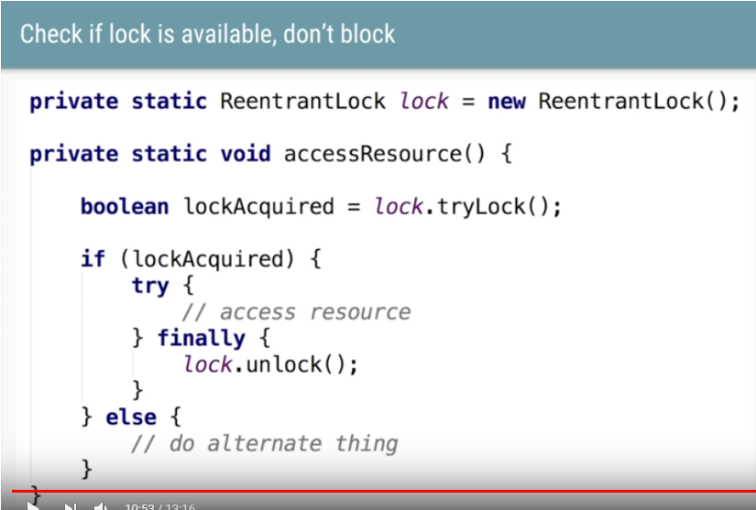

<https://www.youtube.com/watch?v=vHwToYEYvsU&list=PLTyWtrsGknYdqY_7lwcbJ1z4bvc5yEEZl>

SOA: Feature level

Centrally governed architecture

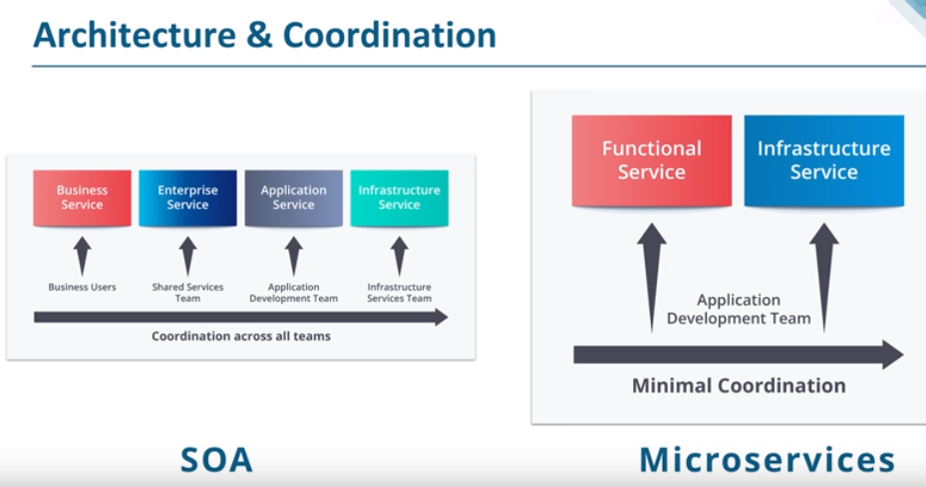

Messaging middleware??? In IBM Infosphere

<https://www.ibm.com/support/knowledgecenter/en/SSZJPZ_8.7.0/com.ibm.swg.im.iis.productization.iisinfsv.overview.doc/topics/wsisinst_arch_tierrelationships.html>

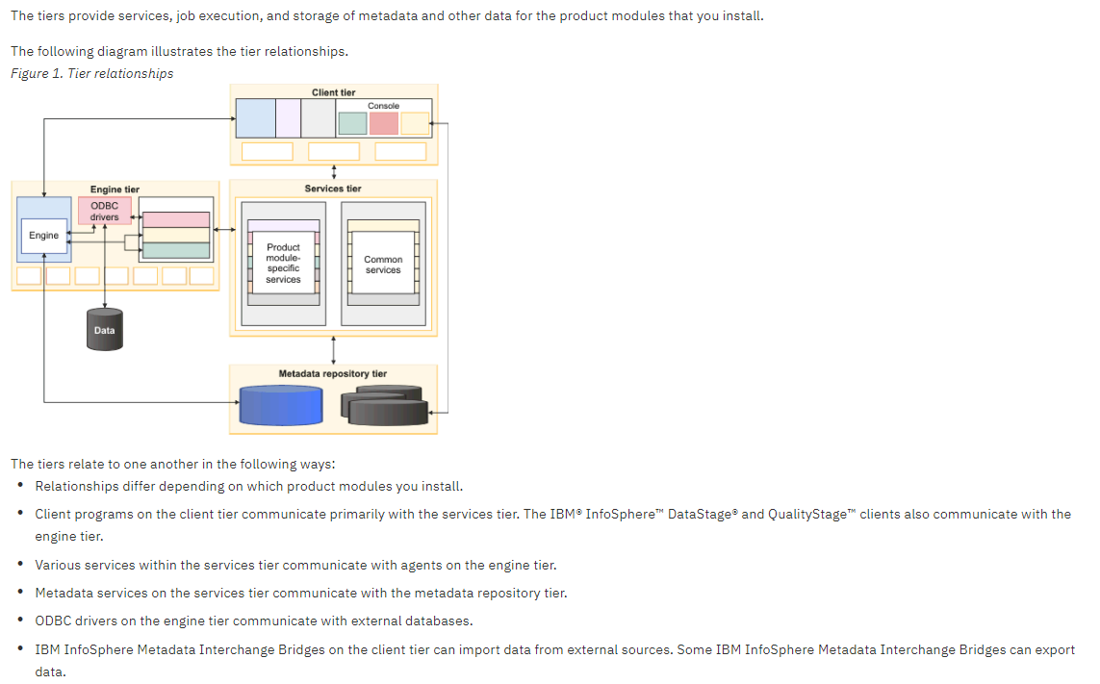

Microserrvices: Task Level

RDBMS:

contraints

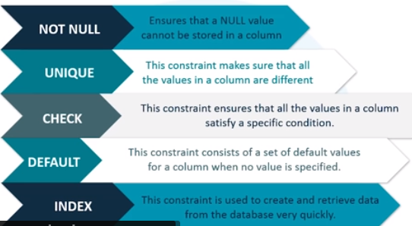

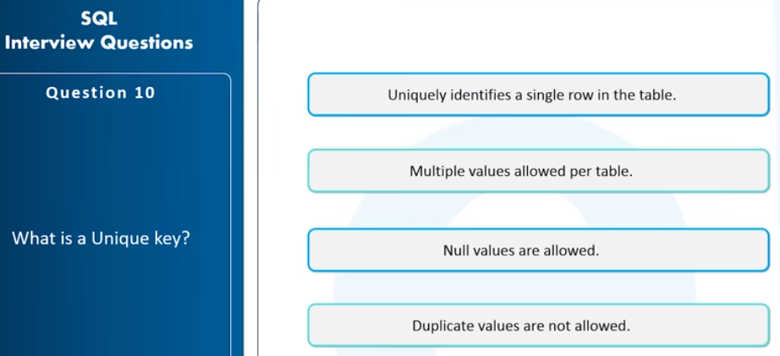

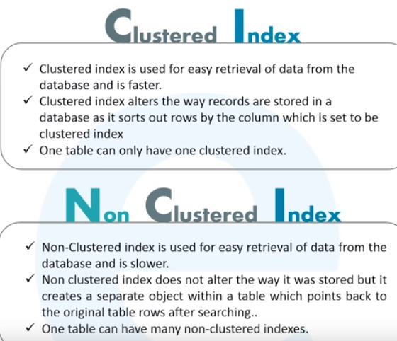

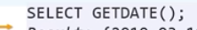

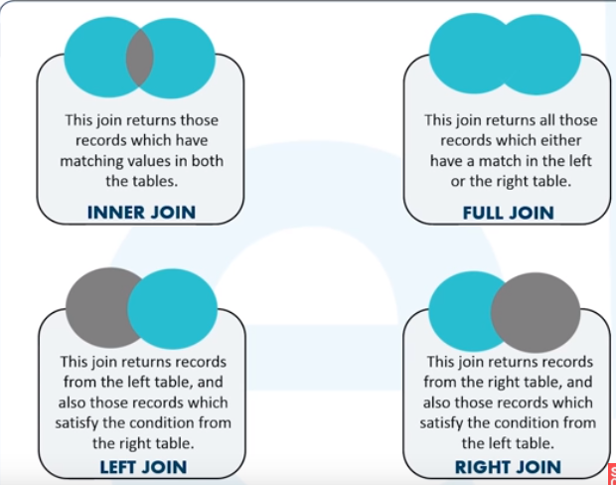

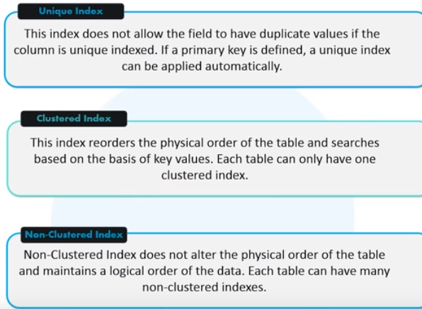

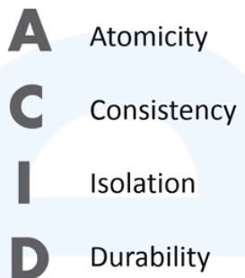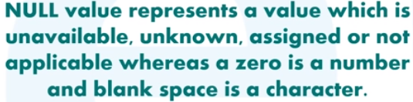

Cross Join vs Natural join

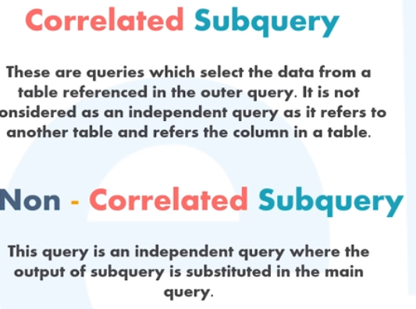

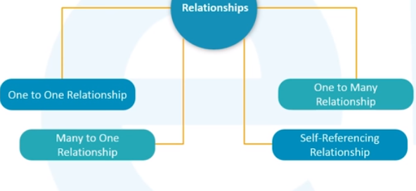

**JAVA INTERVIEW QUESTIONS:**

# How can we maintain Immutability of a class with a mutable reference

# Stack section of memonry contains methods, local variables

# All instance variable and references resides in Heap

# So that can be accessed from anywhere

# Metadata of classes resides in Heap PermGen in java7 and in java8 its replaced with metaspace

# 

# Why We should never invoke GC programmatically from within your code

# 

# 

# 

# Class Loaders :

# 

# 

# 

# Annotation???

# 

# 

# 

# 

# How do threads communicates

# 

# 

>>>>>>>>>>>>>>>>>>>>>>>>>>>>>>>>>>>>>>>>>>>>>>>>>>>

SYSTEM DESIGN

>>>>>>>>>>>>>>>>>>>>>>>>>>>>>>>>

<https://github.com/donnemartin/system-design-primer#study-guide>

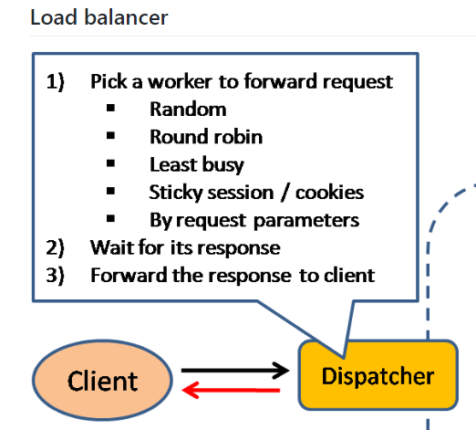

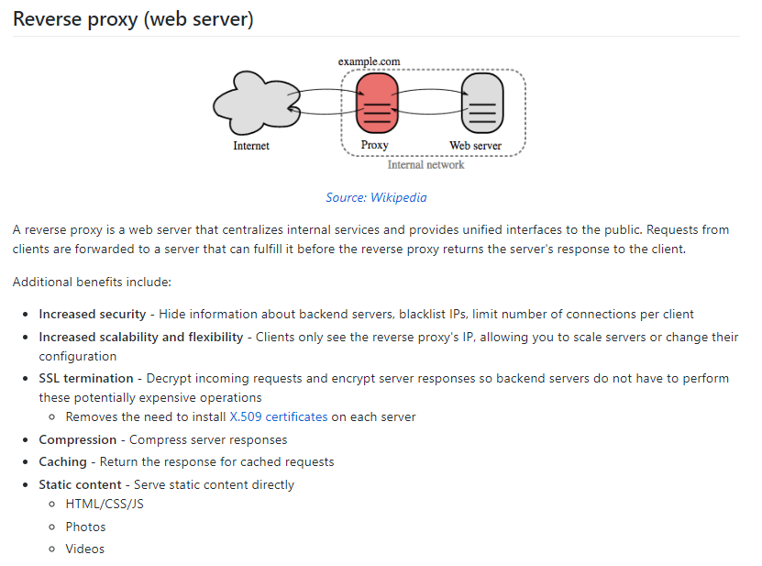

**REST APIs:**

Schema in URI: http or https method

@pathParam is mandatory while @queryParam is NOT

@Produces and @consumes defines MIME type

Can be defined at class level or method level

To override can be defined ta method level

**Spring framework:**

Spring provides following **two types of containers**.

1. BeanFactory container
2. ApplicationContext container

BeanFactory interface has only six methods for client code to call:

Object getBean(String, Class)

boolean containsBean(String)

[**ApplicationContext**](https://docs.spring.io/spring-framework/docs/current/javadoc-api/org/springframework/context/ApplicationContext.html) container adds more enterprise-specific functionality such as the ability to resolve textual messages from a properties file and the ability to publish application events to interested event listeners. This container is defined by the *org.springframework.context.ApplicationContext* interface.

The most commonly used ApplicationContext implementations are

**Fi**[**leSystemXmlApplicationContext**](https://docs.spring.io/spring-framework/docs/current/javadoc-api/org/springframework/context/support/FileSystemXmlApplicationContext.html)

[**ClassPathXmlApplicationContext**](https://docs.spring.io/spring-framework/docs/current/javadoc-api/org/springframework/context/support/ClassPathXmlApplicationContext.html)

[**WebXmlApplicationContext**](https://docs.spring.io/spring-framework/docs/current/javadoc-api/org/springframework/web/context/support/XmlWebApplicationContext.html)

IoC is a design paradigm with the goal of giving more control to the targeted components of your application, the ones getting the work done. While Dependency injection is a pattern used to create instances of objects that other objects rely on without knowing at compile time which class will be used to provide that functionality.

1. using a factory pattern
2. using a service locator pattern
3. using a **dependency injection** of any given below type:
   * a constructor injection
   * a setter injection
   * an interface injection

you can move the bean configuration into the component class itself by using annotations on the relevant class, method, or field declaration. Annotation injection is performed before XML injection, thus the latter configuration will override the former for properties wired through both approaches.

**Spring Bean Scope:**

1. **singleton**: This bean scope is default and it enforces the container to have only one instance per spring container irrespective of how much time you request for its instance. This singleton behavior is maintained by bean factory itself.
2. **prototype**: This bean scope just reverses the behavior of singleton scope and produces a new instance each and every time a bean is requested.
3. **request**: With this bean scope, a new bean instance will be created for each web request made by client. As soon as request completes, bean will be out of scope and garbage collected.
4. **session**: Just like request scope, this ensures one instance of bean per user session. As soon as user ends its session, bean is out of scope.

**Singleton Bean:**

Spring framework does not do anything under the hood concerning the multi-threaded behavior of a [**singleton**](https://howtodoinjava.com/design-patterns/singleton-design-pattern-in-java/) bean. It is the developer’s responsibility to deal with concurrency issue and [**thread safety**](https://howtodoinjava.com/java/multi-threading/what-is-thread-safety/) of the singleton bean.